UI/UX DESIGN DOCUMENTATION
LOGIN
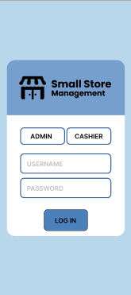
DESCRIPTION:
DASHBOARD
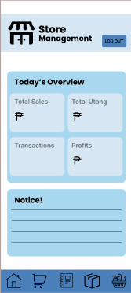
DESCRIPTION:

SELLS
DESCRIPTION:

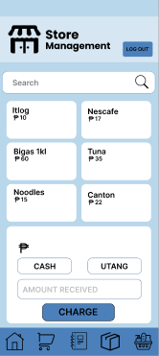
CUSTOMER/UTANG
DESCRIPTION:

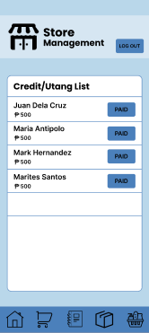

PRODUCTS AND INVENTORY STOCKS
DESCRIPTION:

